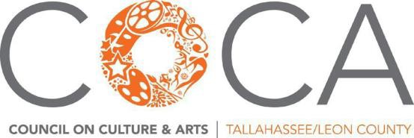
ADVOCACY UPDATE | August 2023

ARTS AND ECONOMIC PROSPERITY (AEP6): Survey collection ended in June. 864 surveys collected (108% of goal), including 230 DEI surveys (103% of goal). 98 organizational surveys approved. (33%increase from AEP5).

AEP6 rollout:
Oct 12: Virtual launch of AEP6 results
Oct 25-27: site visit from Randy Cohen, Americans for the Arts

October 25: STATE OF THE ARTS event, featuring presentation of AEP6 results for Leon Co by Randy Cohen
City Commission presentation (tentative)
Welcome reception for Randy Cohen with Division of Arts & Culture
October 26-27: WFSU Perspectives (tentative)
Meetings with legislators and commissioners

FEDERAL: NEA, NEH & Funding for Arts Agency
Amazing advocacy efforts at the beginning of August produced the following in the FY’24 Senate Appropriations bills passed in the full committee mark-up:https://www.americansforthearts.org/news-room/legislative-news/fy24-appropriations-update

STATE: Why the Arts Matter in Florida 1-sheet: https://www.artsactionfund.org/florida

LOCAL:

The City has not allocated additional funds for the FY24 Cultural Grant program. COCA is working with the City and County to use TDT for a portion of its general operating support, then re-grant that portion of general operating revenue through the FY24 Cultural Grant program.

OTHER FEDERAL: ARTS + SOCIAL IMPACT EXPLORER https://ww2.americansforthearts.org/explorer Ongoing Creative Economy Legislation:
- AEAF/Arts Education for All Act (HR 5581) supports universal arts ed from pre-K through 12th grade.
- CREATE Act (HR 6381 / S.3521) aligns policy to serve those that make our creative economy prosper.
- PLACE Act (HR 6569 / S.3560) bolsters local creative economies and workers in creative industries.
- CERA/Creative Economy Revitalization Act (HR 5019 / S. 2858) grants-creative workers/public projects.
- PATPA/Performing Artist Tax Parity Act of 2021 (S. 2872) for arts workers to deduct business expenses.
- 21CFWP/21st Century Federal Writers Project Act (HR 3054) will authorize a new grant program & create a nationally administered archives for the commissioned writing.
- STAR/Saving Transit Arts Resources Act (HR 2380) local transit authorities control art/non-functional landscaping in federally funded transit projects and historical/heritage societies.

