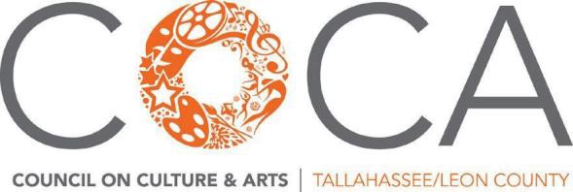

Subcommittee Reports | August 2023 Membership
Build to 300 Campaign | April-September 2023
Distribute membership cards Recruit 3 new members Volunteer at a COCA event

Current Members as of August 17th
Type | Amt | Renewals since  Apr 1 |  | New members since  Apr 1 |  | Lapsed since  Apr 1
Producer | 2 |  |  | 1
Business Sponsorship | 3 |  |  | 2
Business Membership | 9 | 1 |  | 2 |  | -1
Group | 34 | 6 |  | 3 |  | -4
Household | 41 | 7 |  | 9 |  | -1
Individual | 163 | 21 |  | 16 |  | -21
Student | 9 | 1 |  | 1
TOTAL | 261 | 36 |  | 34 |  | -27

Grant Programs
No updates to report

Diversity, Equity & Inclusion
No updates to report

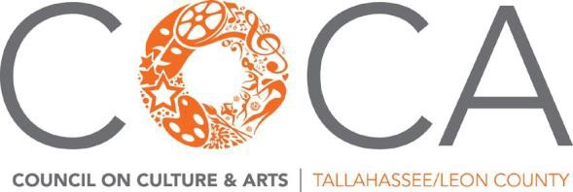

FY23 Board Sub-committees

MEMBERSHIP: To build a strong base of core supporters to COCA’s mission, vision and values, by building membership and economic opportunity. Recruit new members, renew expired memberships, and support new ways to build value in membership investment. Build sponsorships, donations, and business initiatives.

Jennifer Wright, Lucia Fishburne, Paul Lewis, Jr., Katherine Maiorana**, Michelle Personette, Kristen Summers**, Heather Thomas

GRANT PROGRAMS: To maintain a strong grants program that meets the needs of our community. Review grant programs, community, County and City feedback, and make recommendations for any changes to the programs.

Amanda Clements*, Kim Harding, Beth Keating, Katherine Maiorana, Ayne Markos, Rachelle McClure, Carol Hill

DIVERSITY, EQUITY AND INCLUSION (DEI): To continue refining COCA's cultural equity plan and embed it throughout the organization and community.

Nathan Archer, Donmetrie Clark, Haiqiong Deng, Brinda Pamulapati, E. Marie Sissle*, Dan Taylor

*chair
** co chairs

FY23 COCA CONNECTS

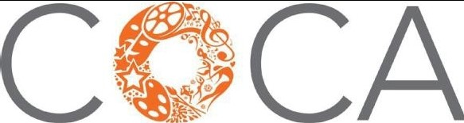
COUNCIL ON CULTURE & ARTS I TALLAHASSEE/LEON COUNTY

