The Capital of Nonprofits: Elevating Our Community and its Economy

Social Media Content Library

Nonprofits help our community thrive, contributing $3 billion each year to our local economy. By supporting the Big Bend’s nonprofit sector, we can energize this growth to new heights! Here’s how: http://bit.ly/Nonprofits_Survey
[UPLOAD VIDEO]
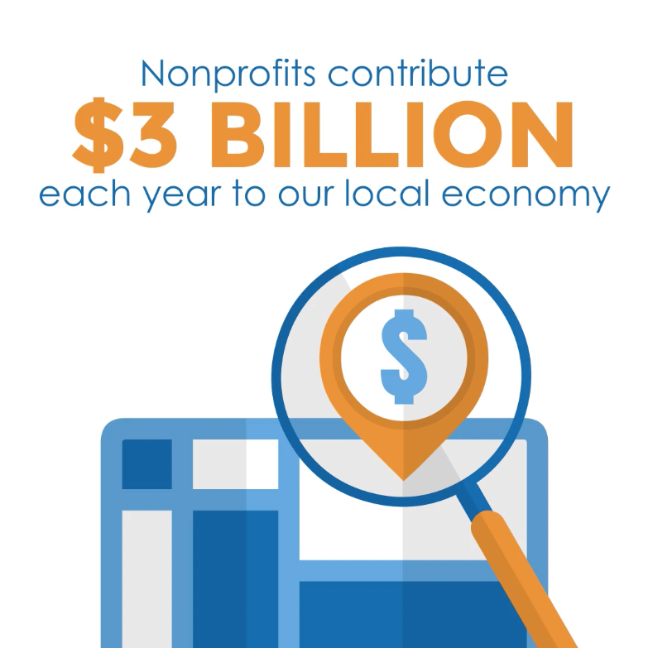

While most Big Bend residents know that nonprofits play a vital role in our community, about half aren’t aware they also drive our local economy forward – contributing $3 billion each year. Learn more: http://bit.ly/Nonprofits_Survey
[UPLOAD VIDEO]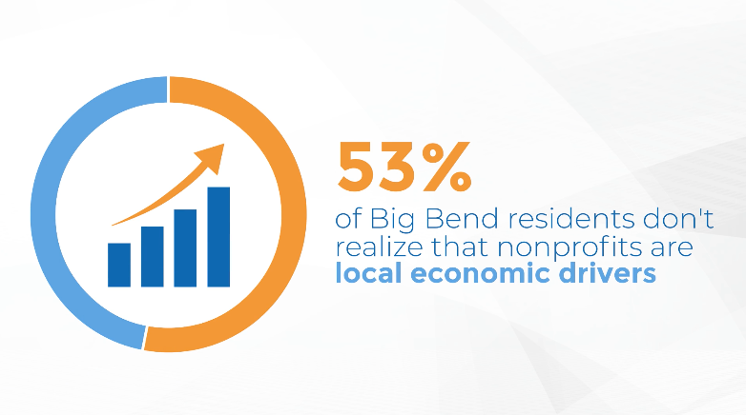

Less than 1 in 3 Big Bend residents say they’ve used or benefited from a nonprofit. But the reality is, most of us interact with and benefit from nonprofits every day without even realizing it. Here’s how: http://bit.ly/Nonprofits_Survey
[UPLOAD VIDEO]
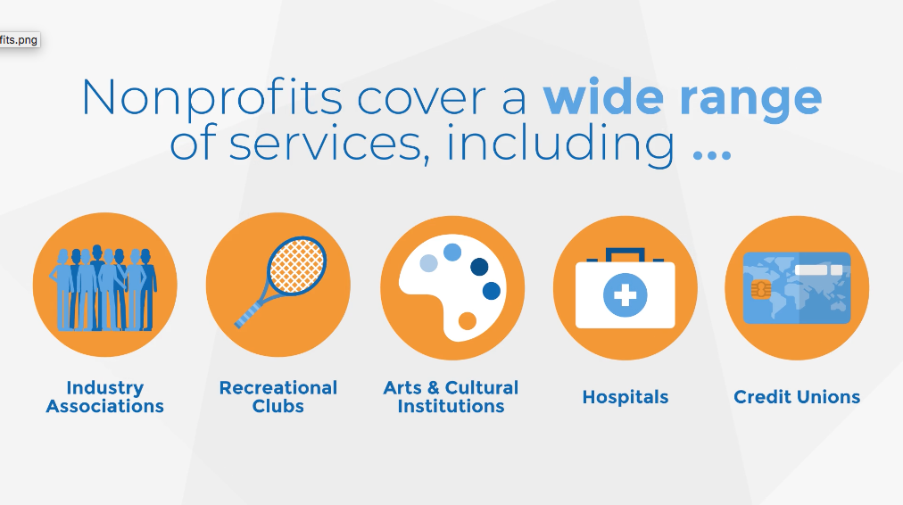

Florida’s Big Bend has a wealth of nonprofit organizations right here in our own backyard, but only 1 in 3 residents realize just how many there are. Learn more: http://bit.ly/Nonprofits_Survey
[UPLOAD IMAGE]
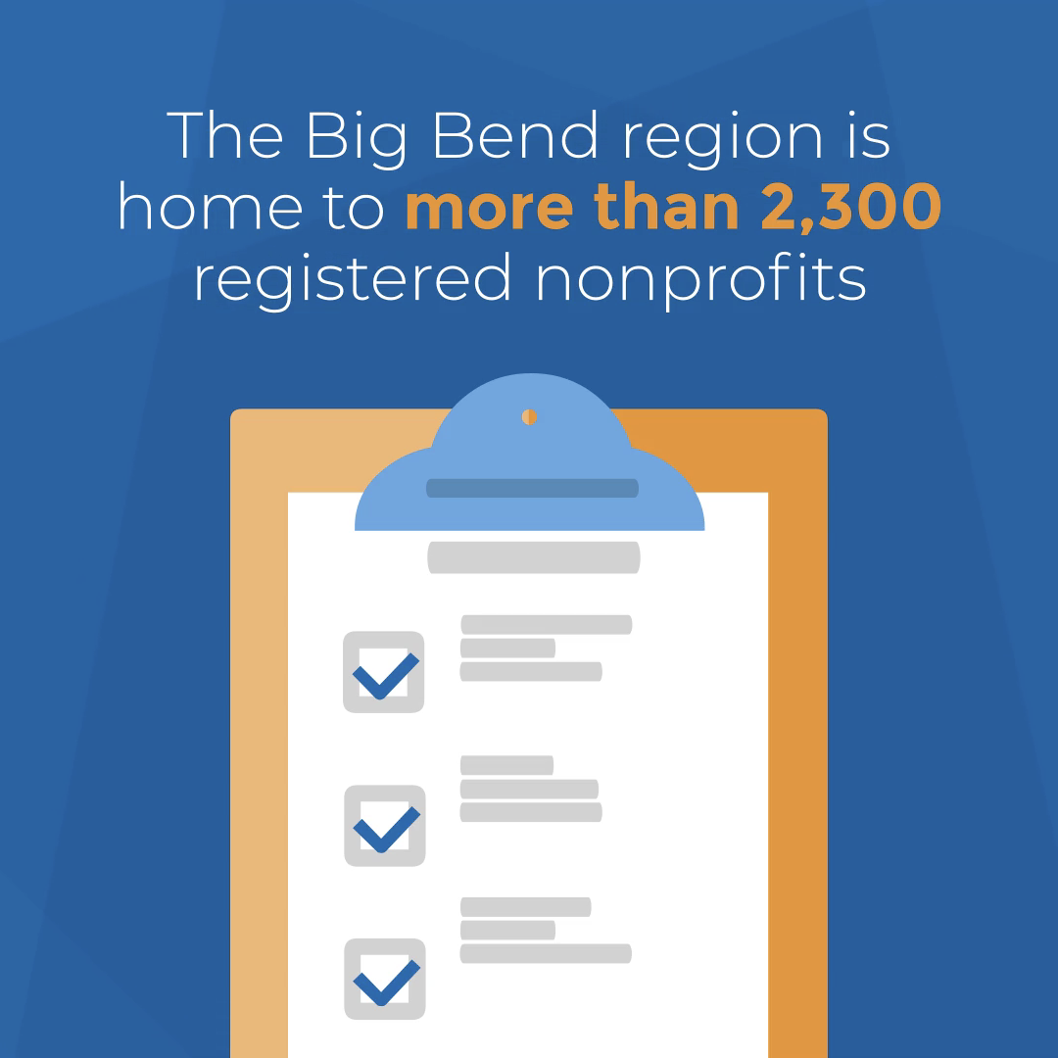

Nonprofits are more than just human service organizations and religious institutions. They also include hospitals, credit unions, and much more. For example, one of Leon County’s three largest employers, Tallahassee Memorial, is a nonprofit – with 5,000+ employees! Learn about nonprofits: http://bit.ly/Nonprofits_Survey
[UPLOAD VIDEO]
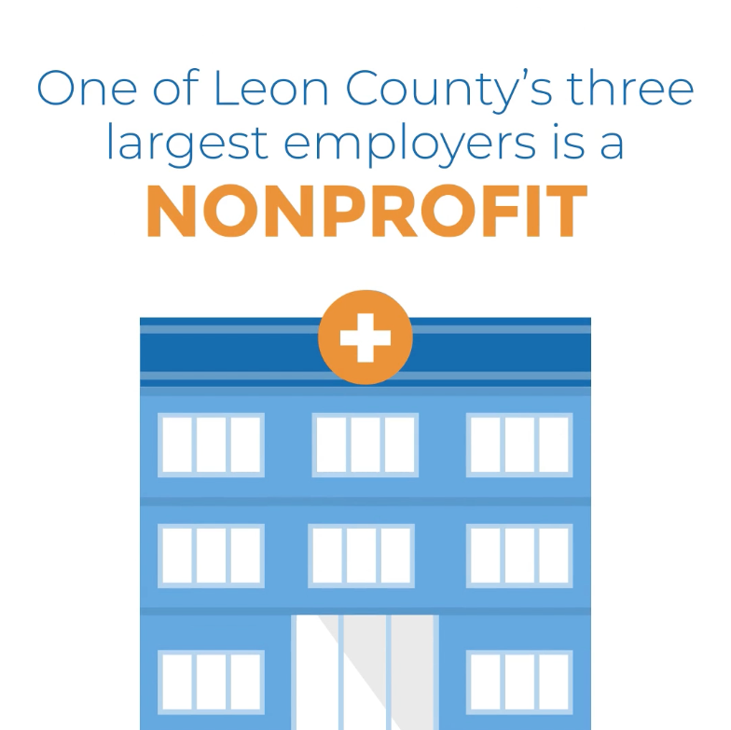

The nonprofit sector contributes $3 billion annually to Florida’s Big Bend. With such a large infusion into our local economy, it’s time to give nonprofits the recognition and voice they deserve!
[UPLOAD IMAGE]
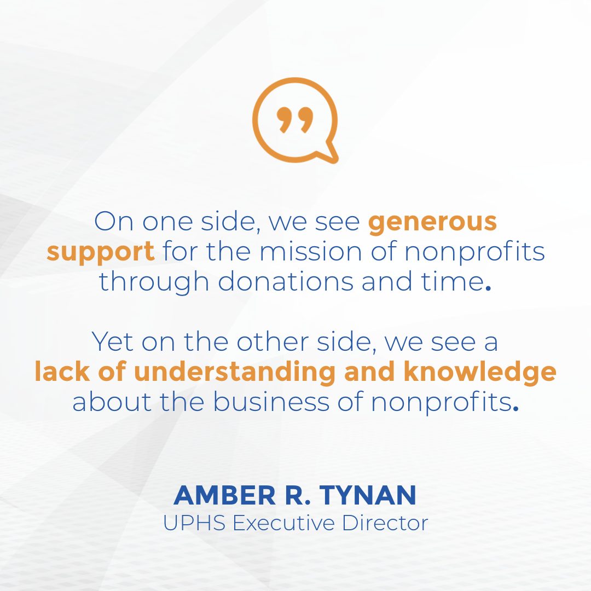

More than 2,300 nonprofits call Tallahassee home, generating 25% of our economic activity. We need to start thinking of the nonprofit sector as our community’s third pillar – alongside government and education!
[UPLOAD IMAGE]
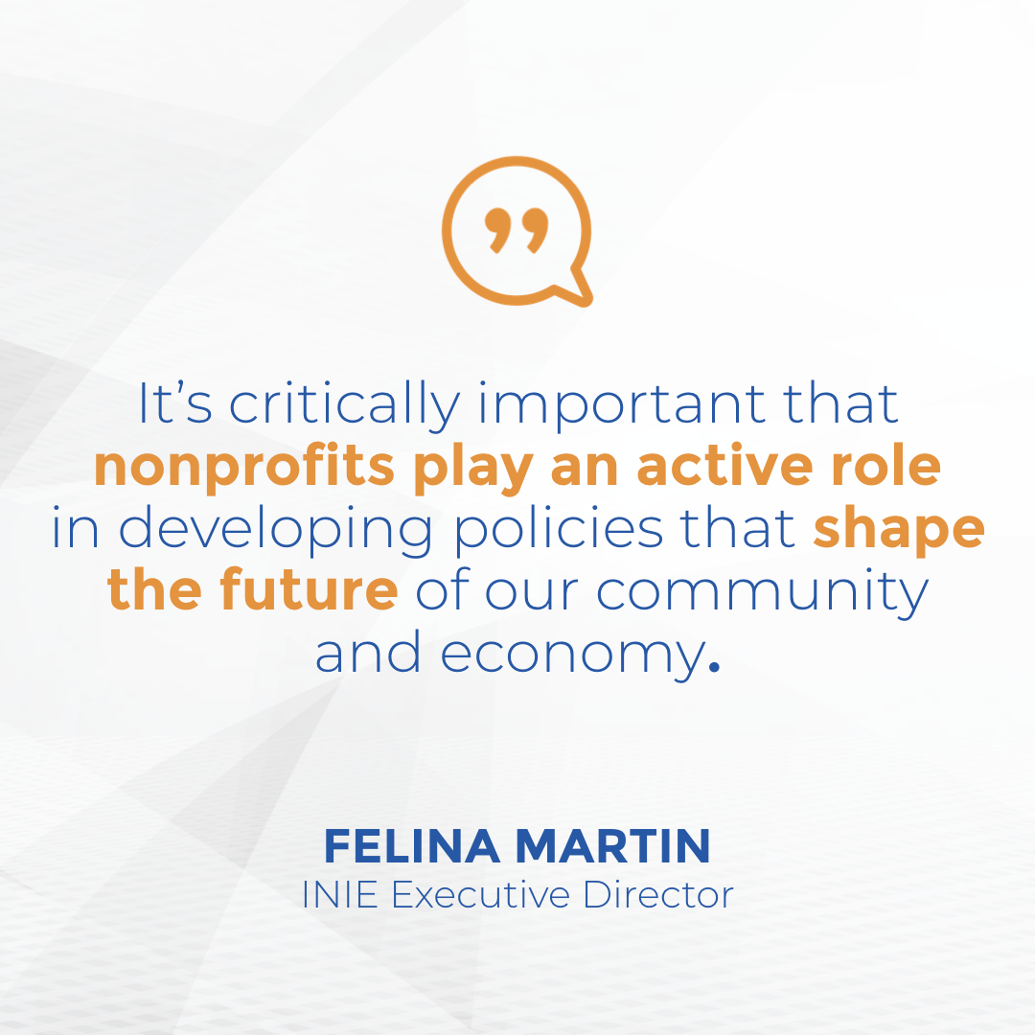

Nonprofits are the backbone of our local workforce, accounting for 1 in 10 jobs and generating 25% of the Big Bend’s economic activity. When we raise the nonprofit sector’s voice, our local community AND economy thrive!
[UPLOAD IMAGE]
